

Year 7 Science 2017 – EES 2 Topic Test Name: _____________

Total Mark: ____/20
SECTION 1: MULTIPLE CHOICE (1 mark each)
Circle your answer in the section on page 2.

The first six questions are about the following diagram of the structure of the Earth.
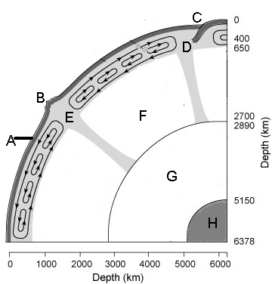

- The part of the Earth that is labelled A is called the
  - crust.
  - mantle.
  - magma.
  - core.

- The solid inner core is labelled
  - E
  - F
  - G
  - H

- The area that is labelled D is called
  - the subdivision.
  - the subduction zone.
  - the expansion zone.
  - the unstable zone.

- You would find a lot of earthquakes and volcanoes around
  - A
  - B
  - C
  - D

- The thickness of the liquid outer core is approximately
  - 2050km
  - 2260km
  - 2890km
  - 5150km

- The thinnest layer of the Earth is the
  - crust.
  - mantle.
  - outer core.
  - inner core.

- The gas that makes up about 78% of the air in the Earth’s atmosphere is
  - nitrogen
  - oxygen
  - carbon dioxide
  - argon

- The upward thrust of an object floating in water is known as
  - pressure
  - friction
  - gravity
  - buoyancy

- Water vapour in the air is known and measured as
  - snow
  - humidity
  - wind
  - hail

- The layer of atmosphere closest to the Earth and containing about 75% of the air is the
  - thermosphere
  - ionosphere
  - troposphere
  - stratosphere

M/C Answer Section (Circle your choice)

- A B C D 6. A B C D

- A B C D 7. A B C D

- A B C D 8. A B C D

- A B C D 9. A B C D

- A B C D 10. A B C D

Total Mark for M/C Section: ___ /10

SECTION 2: WRITTEN
Write your answers in the spaces provided.

- Use the following diagram to allocate numbers to the following terms: (3 marks)

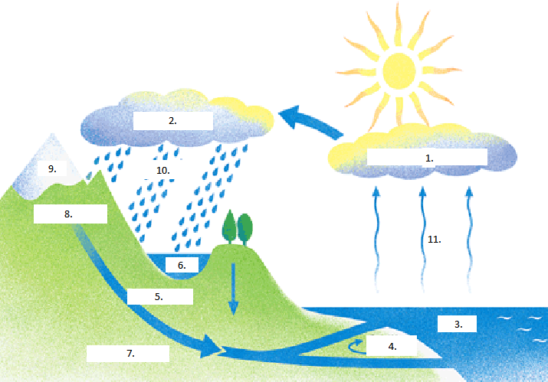

Snow - _____ Cloud Formation - _____

Precipitation - _____ Surface runoff - _____

Lakes - _____ Oceans - _____

Evaporation - _____ Delta formation - _____

Rain clouds - _____ Ground water flow - _____

Deep rock layer- _____

- Label the atmospheric levels (1-5)
(2 marks)
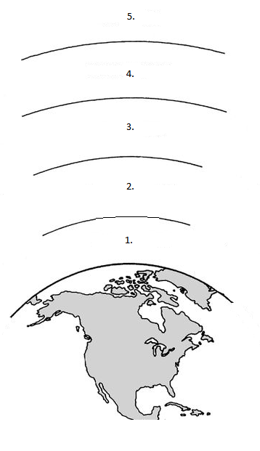
- __________________

- __________________

- __________________

- __________________

- __________________

- Resources and classified as renewable and non-renewable. Classify the following as renewable (R) non-renewable (NR). (3 Marks)

  - Petrol _____

  - Plantation timber _____

  - Nuclear fuel _____

  - Solar electricity _____

  - Geothermal energy _____

  - Wind power _____

  - Tidal power _____

  - Natural gas from biomass _____

- Plastics are common materials used for many familiar uses.
(2 marks)
  - State two (2) advantages of plastics:

______________________________________________________

______________________________________________________

  - State two (2) disadvantages of plastics:

______________________________________________________

______________________________________________________

Total Mark for written section: ____/10

END OF TEST

